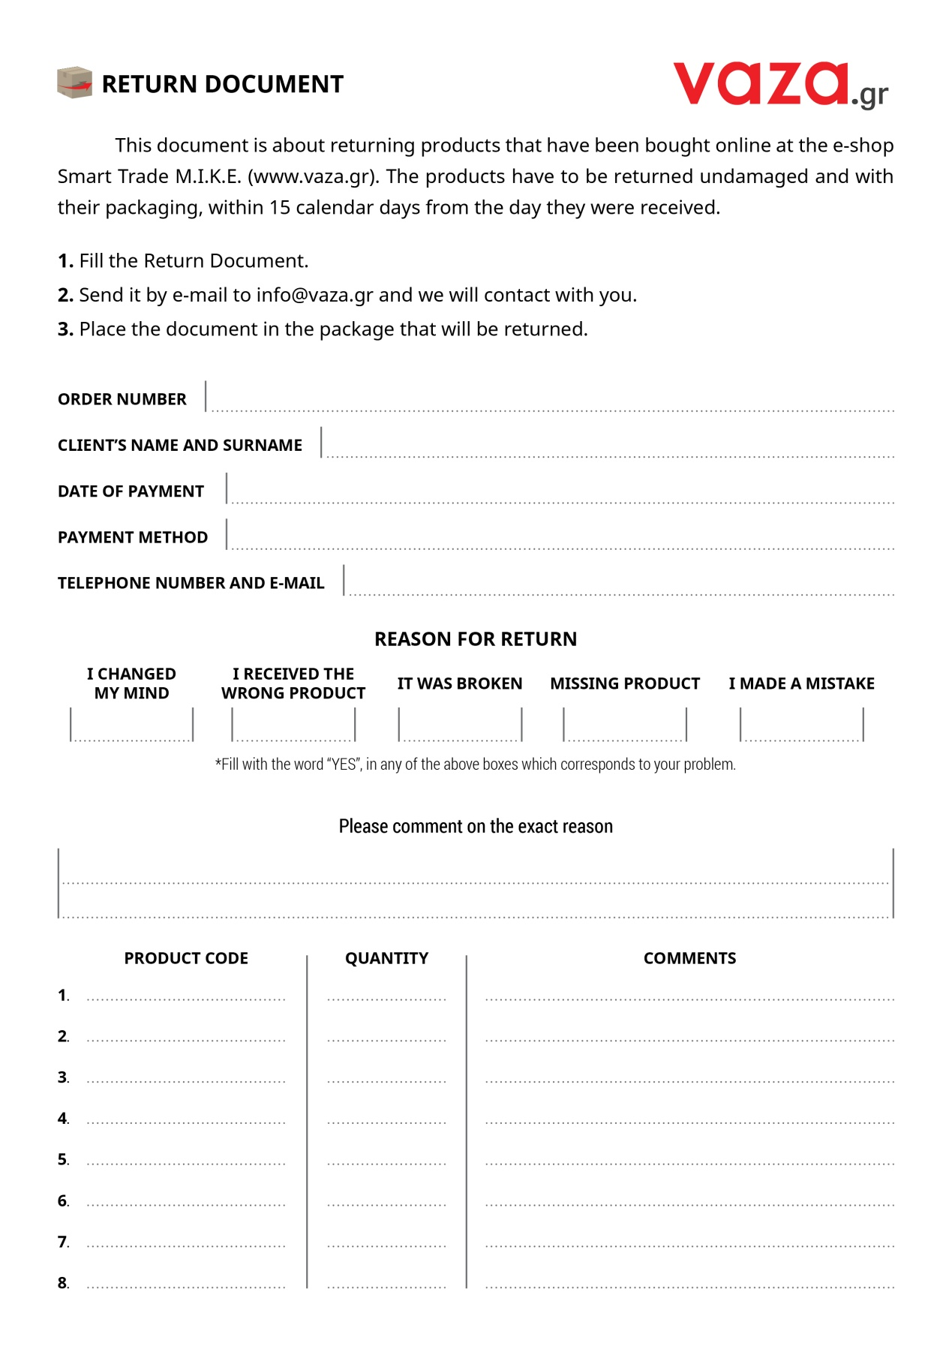

*\* For a larger quantity of products please contact us.*